1ST SEMESTER GROUP PROJECT

**Circle: 109**

Names

-Akeju Akingbera Samson

-Chimdi Eke

-Chukwuemerie Oyonma

-Henrietta

-Ibroxyl

-John maina

-Kachi Ibezim

-Kashirim Gospel Chigozie

-Olamilekan Olowolagba

-Onyekachi Chris(**Circle lead**)

**Project:**

Good morning all, for your group projects as a circle, you are expected to choose any python package, import it to your notebook, demonstrate how it works, and how it can be used to solve a problem.

show the package like you built it and you want to advertise it.

Note: it is not compulsory to use a dataset if your chosen package doesn't work with datasets, if your chosen package implements a dataset, feel free to choose any one.

**OPENPYXL**

Openpyxl is a Python library used to read and write Excel 2010 xlsx/xlsm/xltx/xltm files.

*Importing the package:*

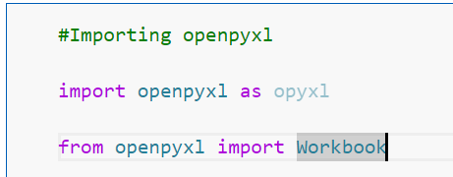

It's a powerful tool that allows you to automate tasks like:

**Reading data from Excel files**: You can use openpyxl to access and manipulate data in Excel files, such as extracting specific cells, rows, or columns.

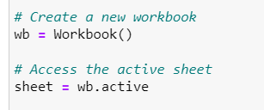

**Writing data to Excel files**: You can use openpyxl to write data to Excel files, such as creating new worksheets, formatting cells, and adding charts.

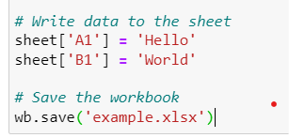

**Automating repetitive tasks:** You can use openpyxl to automate tasks that you would otherwise have to do manually in Excel, such as copying and pasting data, or generating reports.

For example, passing the names of movies in a folder to a list on an excel sheet.

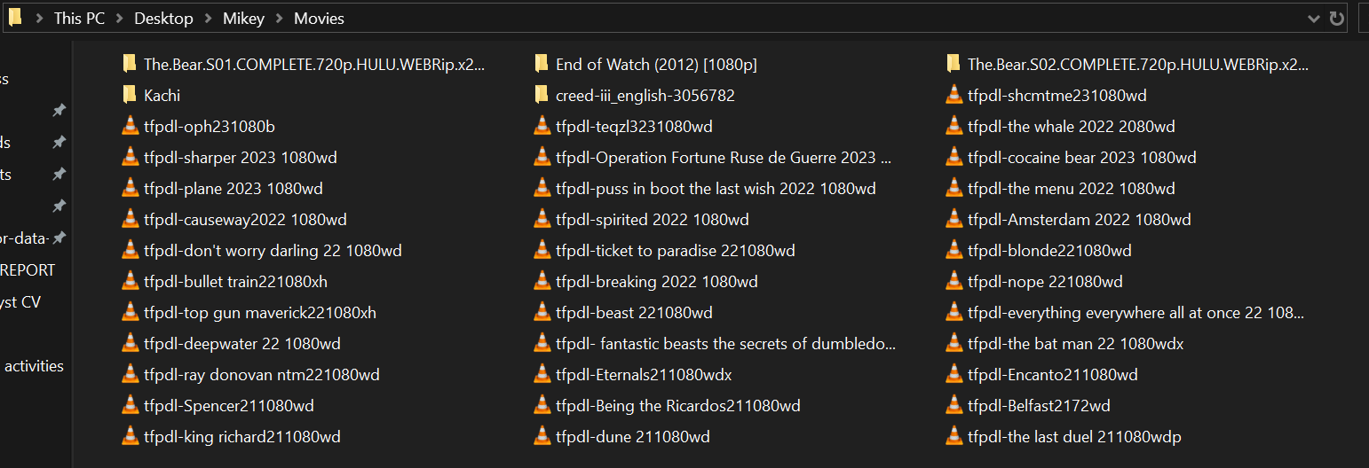

The coding:

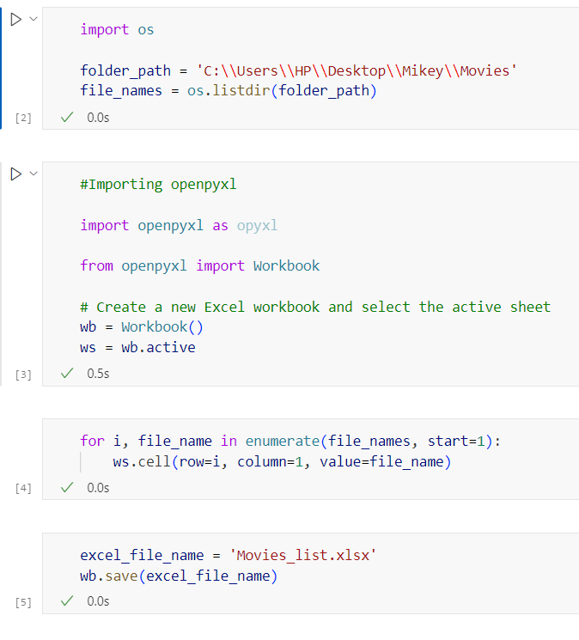

The result:

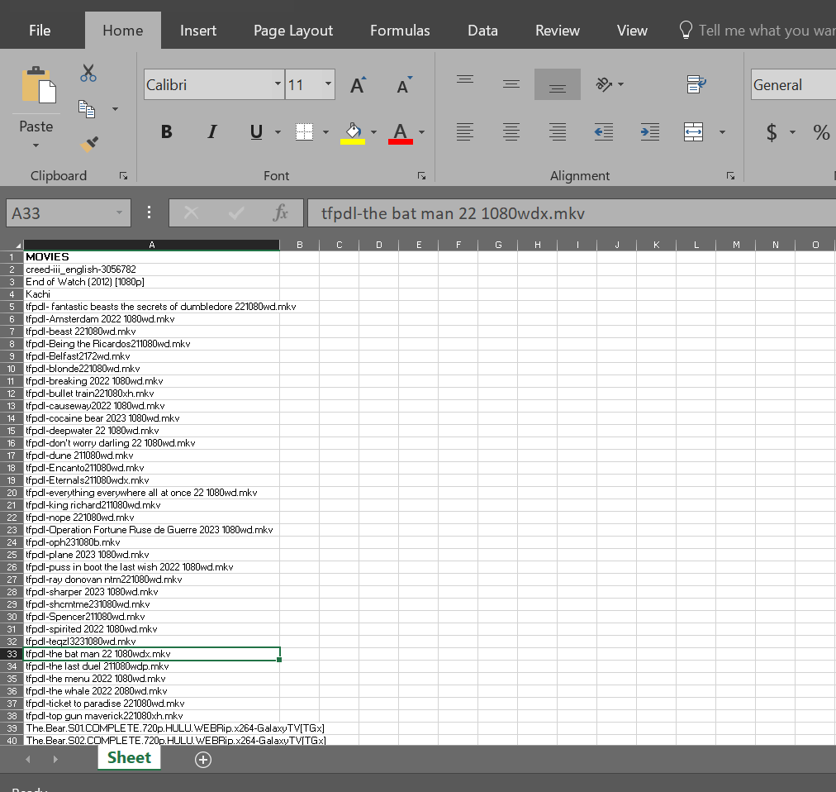

*An ordered list of movies and other items in the folder.*

Accessing Cells and Ranges: You can access and modify individual cells and ranges within a worksheet.

Example: Reading data from a specific cell.

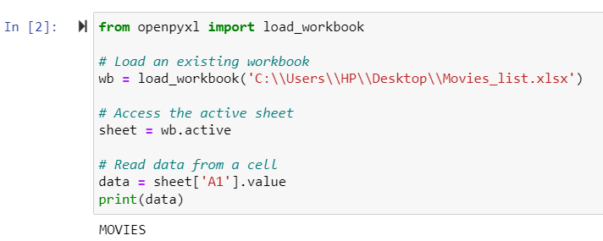

**Working with Styles:** openpyxl allows you to apply styles to cells, such as font formatting, borders, and colors.

Example: Applying styles to cells.

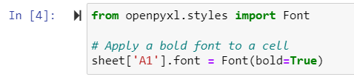

**Working with Formulas:** Formulas can be added to cells, and openpyxl will handle the calculation.

Example: Adding a formula to a cell.

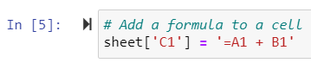

**Handling Rows and Columns:** You can insert, delete, and manipulate entire rows and columns.

Example: Inserting a new row.

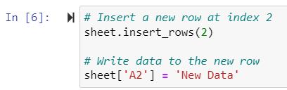

**Working with Charts and Images:** openpyxl supports the addition of charts and images to worksheets.

Example: Adding an image to a worksheet.

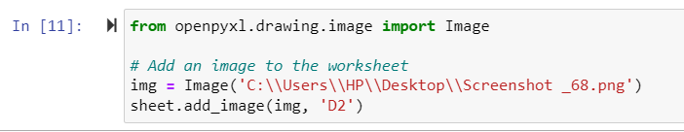

**Handling Multiple Worksheets**: You can work with multiple sheets within a workbook.

Example: Creating a new sheet.

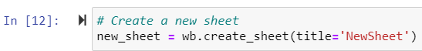

Here are some of the key features of openpyxl:

**Easy to use:** Openpyxl has a simple and intuitive API that makes it easy to get started, even if you're not a Python expert.

Powerful: Openpyxl provides a wide range of features that allow you to do almost anything you could do in Excel.

**Flexible**: Openpyxl can be used with a variety of data sources, such as databases and CSV files.

**Well-documented:** Openpyxl has extensive documentation that makes it easy to learn how to use the library.([Openpyxl documentation](https://www.scribd.com/document/304961255/openpyxl)).